**Name: Gauri**

**ID: 2016UCP1425**

**Batch: B1**

1-  
Create a procedure to find factorial of number provided by user

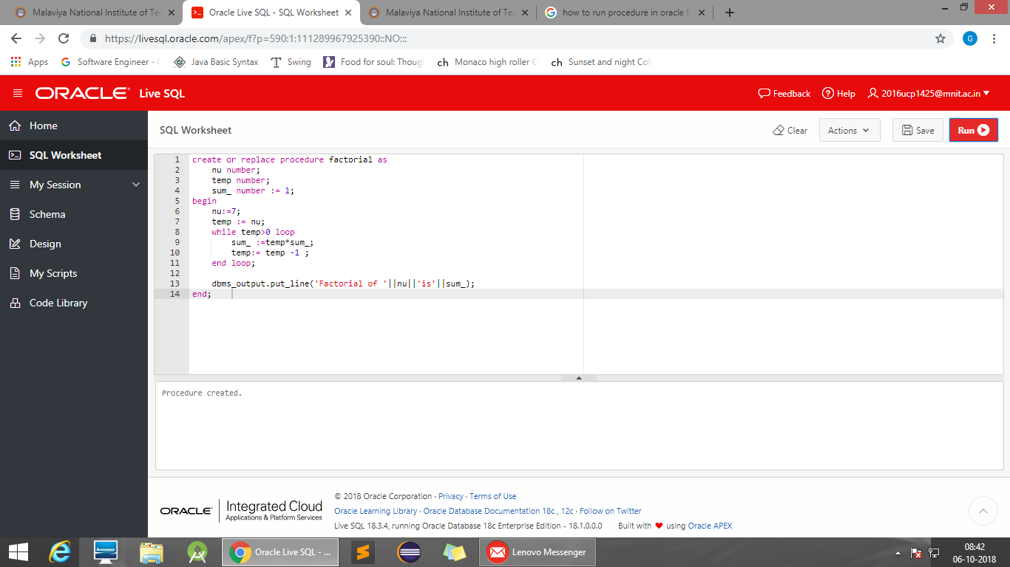

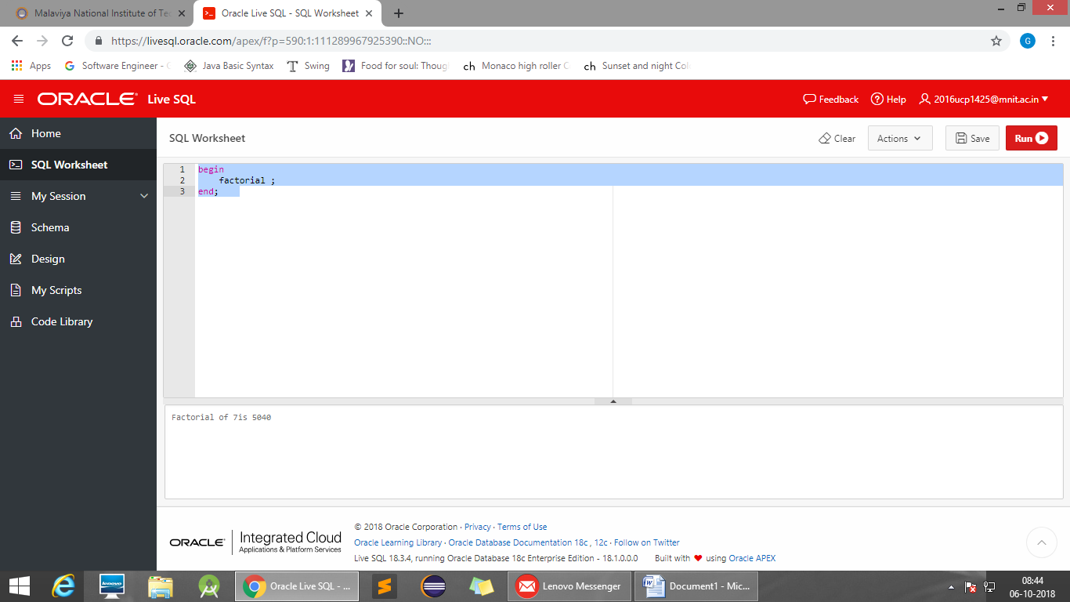

2.Procedure for reversing a number provided by user

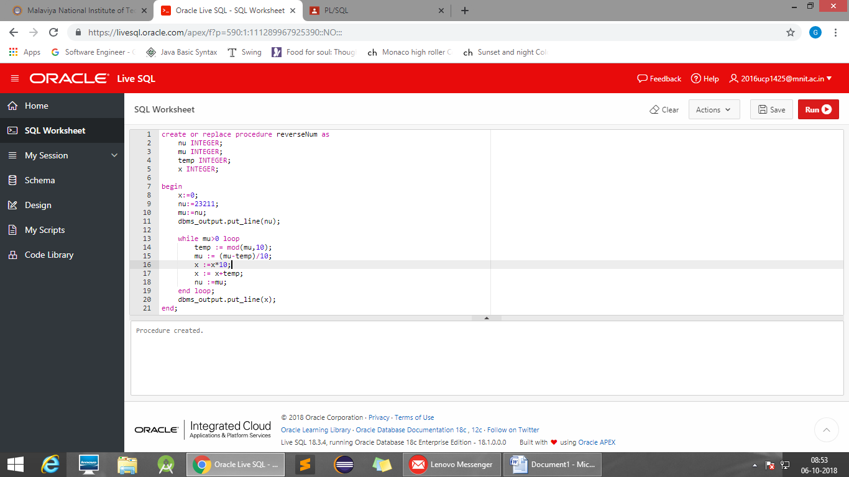

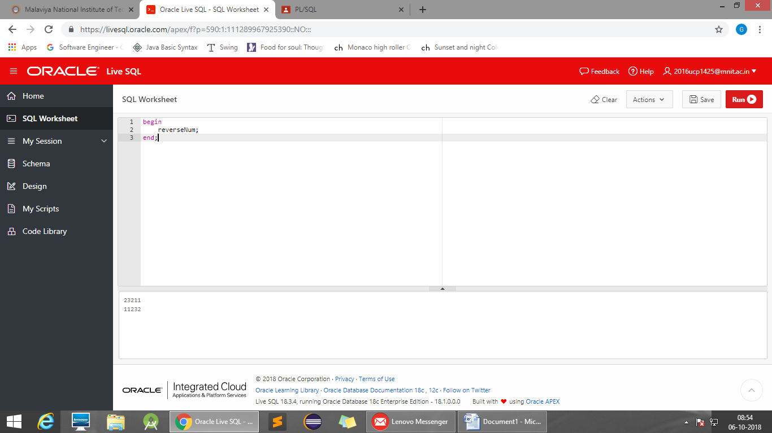

For que 3,4,5  
Employee(Eno,ename,dno,salary,job)  
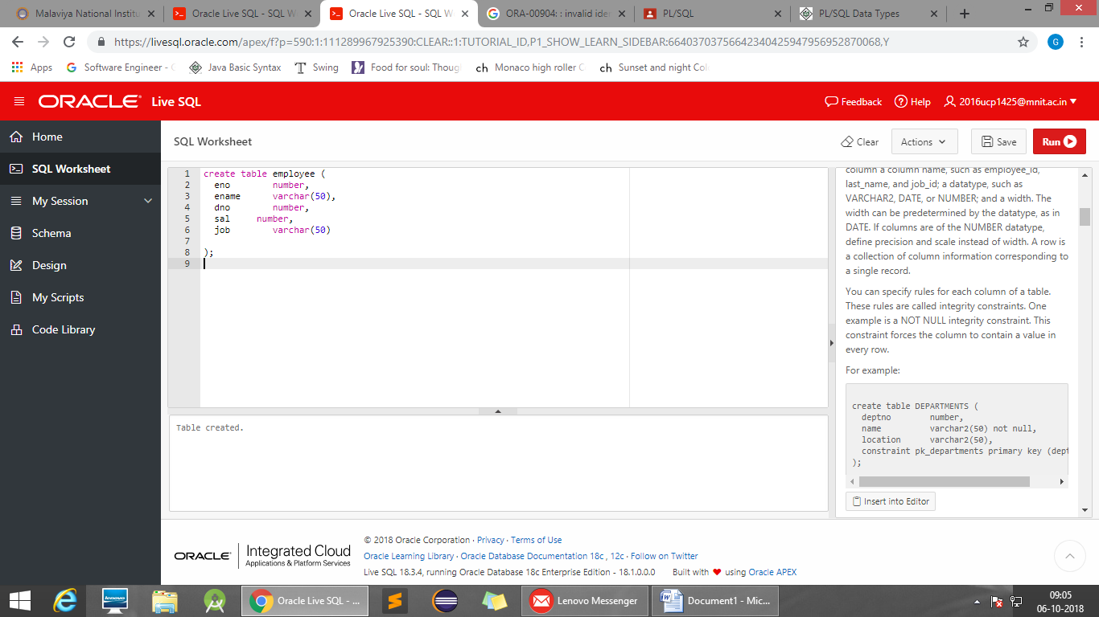

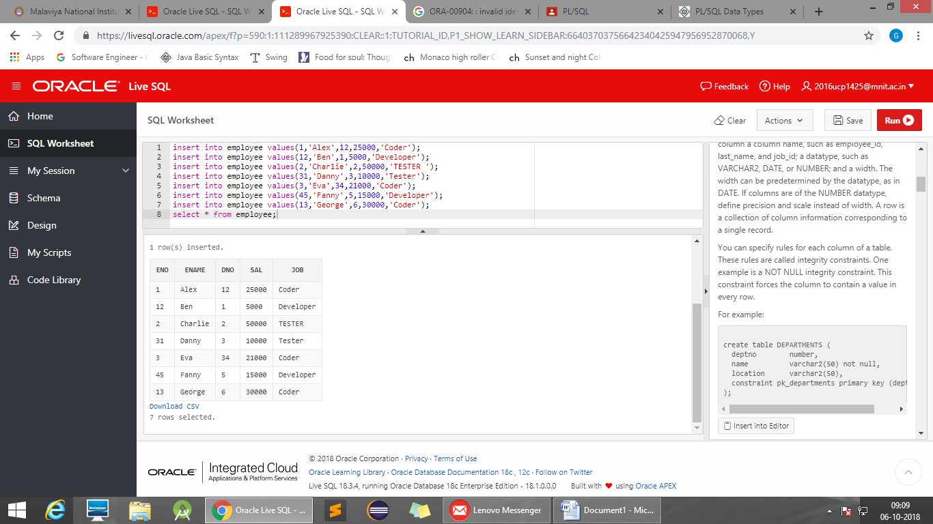

3-  
Delete tuples for employee where eid is greater than 10 and display number of rows affected.

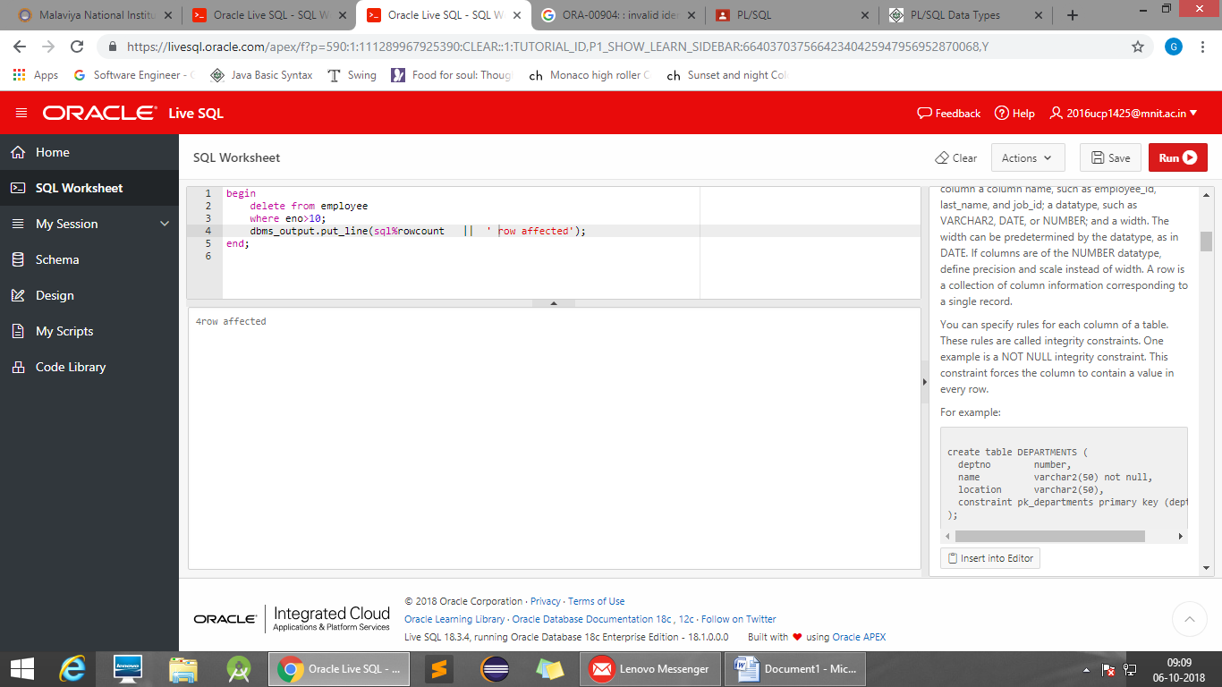

4-  
Update record in table set salary =50000 where salary is greater than 20000 and less than 30000  
And display number of rows affected.

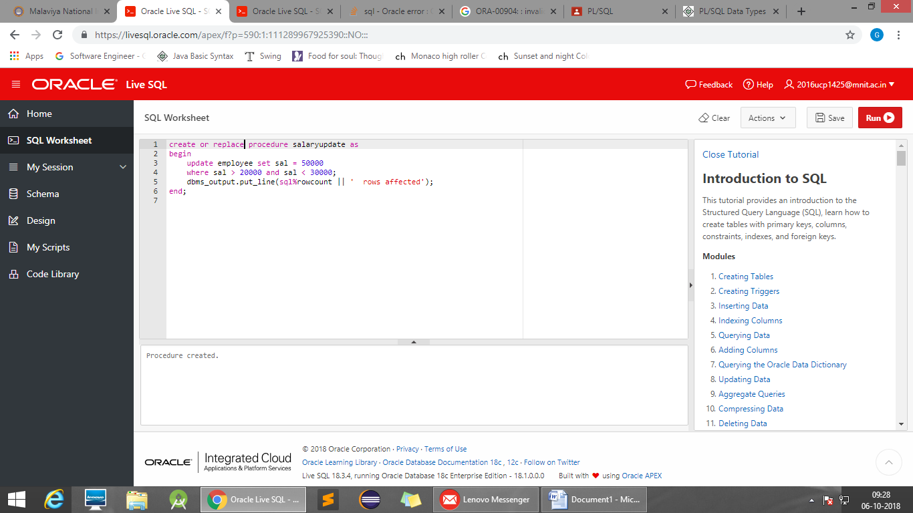

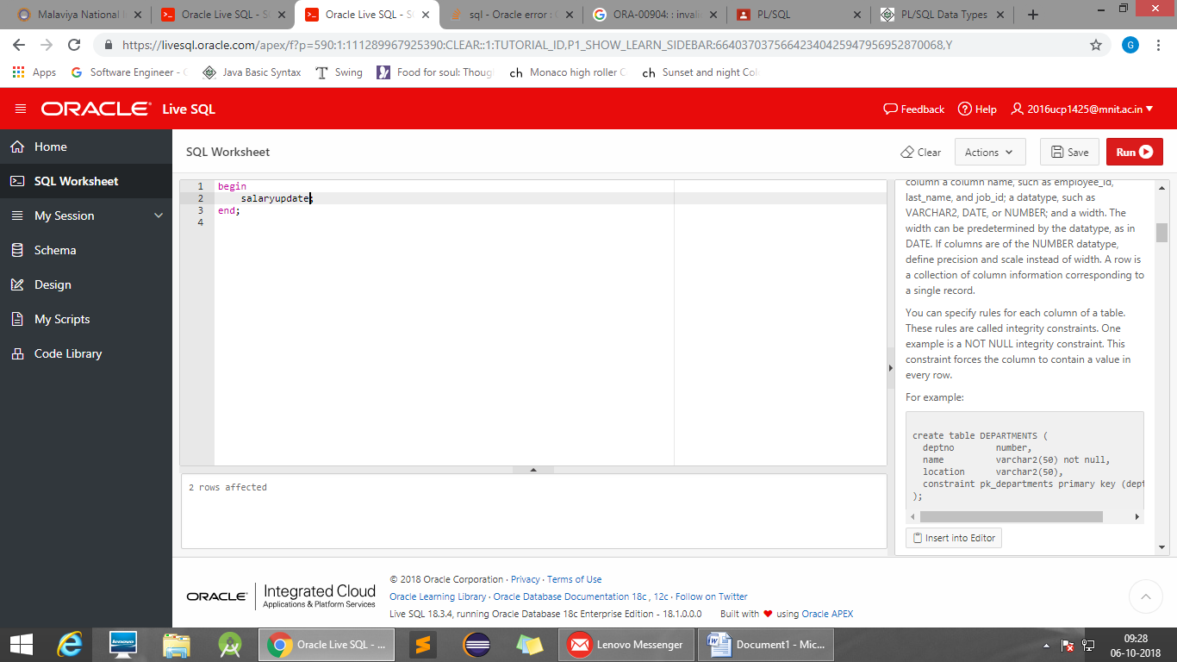

5-  
Display the employee number and number of rows selected having salary equal to 17000

